CPD Programme Pathways
@Southport Learning Trust

“Every teacher needs to improve, not because they are not good enough, but because they can be even better.” Dylan Wiliam

Southport Learning Trust is committed to supporting the Professional Development of all teaching and support staff. Our aim is to develop within all of our schools, a collaborative environment which encourages innovation and promotes professional learning.
All staff in the Trust are involved in a range of professional development activities, supported by a blended learning approach consisting of face to face training and E-learning opportunities. These activities include:
- Enquiry based classroom research
- Whole School Training Days
- The Performance Management process
- Self-directed learning through professional associations
- For teaching staff, Peer Observation
- National Professional Qualifications in Leadership
- TA / Support staff development programmes
If improving the effectiveness of teaching opens the door to raising pupil achievement, CPD holds the promise of acting as a key. John Hattie’s influential research in “Visible Learning: A Synthesis of over 800 meta-analyses relating to pupil achievement” reflects the importance of CPD, showing how it features in the top 20 of practices analysed, with a large effect size of 0.62 on pupil achievement.

CPD has the potential to raise the bar and close the gap in attainment for our disadvantaged students.

Through providing dynamic professional learning experiences for staff, Our CPD programme is planned to deepen and further the knowledge and expertise of staff at all stages of their careers. The DFE explains how:
“High-quality professional development requires workplaces to be steeped in rigorous scholarship, with professionals continually developing and supporting each other so that pupils benefit from the best possible teaching.”
DFE: Standards for Teacher’s Professional Development 2016
For recently qualified staff, the aim is to get them working at a high level very quickly. For existing staff, we seek to provide opportunities to collaborate and share their expertise with others, both inside and outside of departments. We seek to provide support and challenge, and a commitment to professional learning, reflecting the key principles of our curriculum for pupils. In the same way, we continue to strive for personalisation through the CPD programmes we offer.

MODEL OF PROFESSIONAL LEARNING @Southport Learning Trust
The model of professional learning captures the core features and processes of professional learning. The central focus is the teacher-as-learner, the deeply interconnected relationship between the teacher-as-learner and children and young people, and the impact of this relationship on the learning experience.

At Southport Learning Trust, we believe that professional learning should be:
- Challenging and lead to developing thinking, knowledge, skills and understanding;
- Underpinned by developing skills of enquiry and criticality;
- Interactive, reflective and involve learning with and from others;
- Informed and supported by Professional Standards and other educational policy;
- Leadership of and for learning is supported, promoted and sustained.
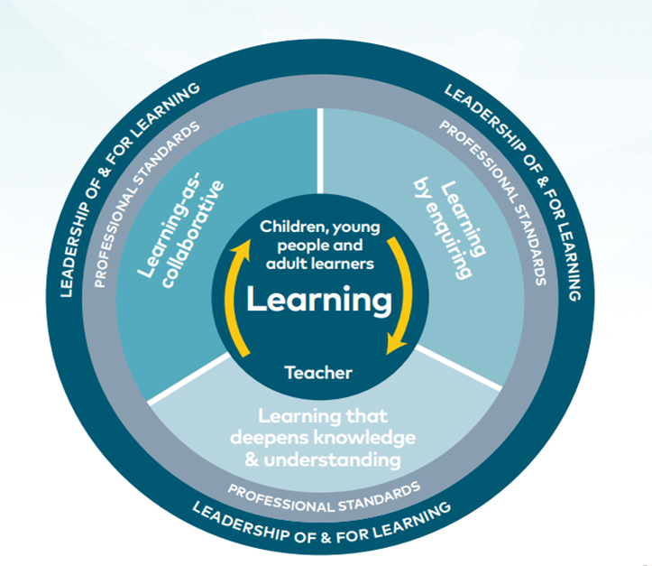

CPD options are offered through our INSET programme, delivered as twilight sessions throughout the year. Enquiry is at the forefront of this programme, encouraging staff to reflect on current practice, to engage with current research and to implement and review strategies to enhance the effectiveness of learning in their classrooms. Central to this approach is working with staff at all levels to identify what staff need to develop in order to respond to changing pupil and school needs.

In addition, voluntary CPD sessions will be on offer throughout the year, covering a wide range of topics and delivered by our own staff, reflecting the strengths and expertise we have as within the Trust.

Southport Learning Trust CPD Pathways
Induction Programme.
All staff attend a one day induction programme before they join their school.
This involves sessions which focus on school ethos, policies and procedures, including Safeguarding and Child Protection, Internet Safety and acceptable use, an introduction to our teaching and learning model and pastoral system, including the school behaviour policy.
Each newly qualified teacher is assigned a school mentor who it is intended, will support them through their transition throughout their first year in the profession.

CPD Pathway 1: NQT Programme
The New Teacher Programme support package includes a programme of ten sessions that focus on ‘the basics’ in relation to our model of teaching and learning and reflecting the statutory guidelines for NQT induction. There will be five Core Development sessions offered over the year as part of the whole school voluntary CPD cycle. In addition, a further five support meetings will be offered by subject mentors during the first term to meet the development needs of the NQT. The broad foci for these meetings will be as follows:
Session | Week | Focus
1 | 2 | Settling in. Q&A. Support mechanisms. Reflection.
2 | 3-4 | Classroom climate and Behaviour for Learning. Experiences so far.
3 | 4-5 | Using pupil data to inform planning.
4 | 8-9 | Marking and feedback- impact so far.
5 | 10-11 | Pastoral role in promoting progress

Each NQT will have the support of a subject mentor in their department as well as the whole school professional mentor.
Subject mentors and NQTs meet once each half term in terms 2 and 3, following a developmental observation by their subject leader and a member of SLT/ Whole School Mentor as required. DOLs and HODs will also carry out observations as part of our quality assurance cycle.
NQT Support Structure

CPD Pathway 2: Developing Teacher Programme
This pathway is offered to all of our second year teachers and staff who have recently joined the schools. The programme has been designed to deepen staff understanding and expertise in line with our Teaching and Learning development priorities, as outlined in the school improvement plan.
Developing teachers will meet with AHT for Teaching and Learning early in the Autumn Term to reflect on their individual development needs and aspirations. An action plan for the year will completed, factoring in whole-school CPD options and individual needs. In addition, five core development sessions within the voluntary CPD cycle will be identified to enhance development.
A further meeting will take place with AHT for Teaching and Learning in the spring term, followed by a final reflection and review in the summer term.

CPD Pathway 3: Developing Excellence Programme
This pathway will be offered to all staff to strengthen the school’s excellence in Teaching and Learning through enquiry based classroom research. In addition, staff who are on Pathway 3 can potentially access National Professional Qualifications according to their development needs and the development priorities of the school.
NPQML is aimed at individuals with responsibility for leading a team, including leaders of key stage, subject, curriculum, heads of department and pastoral leaders. This includes those who are, or are aspiring to be, a middle leader.
NPQSL is for those individuals who not only have responsibility for leading a team, but are also involved in leading a range of issues that affect the whole school or organisation. This includes those who are, or are aspiring to be, a senior leader.

CPD Enquiry Model 2018-19
As practice based research has proven to be a highly effective, personalised CPD process, our approach this year will be led by an enquiry model.
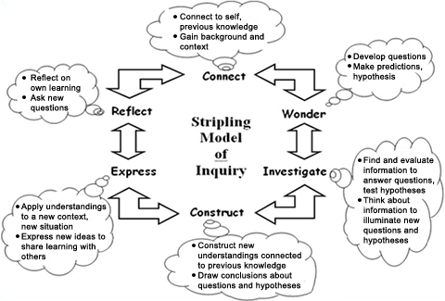

Reflecting our current developmental needs in the light of curriculum changes across the school, the following areas have been identified as our CPD foci this academic year:
- Enhancing Reading: enhancing progress
- Developing MAGT provision across your subject
- Promoting positive mental health for exams
- Developing feedback: enhancing progress
- Developing metacognition in your subject
- Acquiring subject excellence: becoming an examiner / developing links with KS2/5

Five twilight sessions, led by members of SLT and other staff, will be offered as a framework for the enquiry-based development which all staff will undertake. This development will also form one of the performance management objectives for all staff as in previous years. Observations as part of the performance management review cycle will be conducted to support the work of staff and feedback offered to support next steps development. We have a vibrant learning culture @ Southport Learning Trust and staff will be encouraged to share their research throughout CPD newsletter ‘PG Tips’ and the school’s social media platforms.

Development which has taken place over the year will be shared and celebrated at a ‘Teachmeet’ event in the summer term.

Personalised CPD Pathways.
In some instances, staff may require a more personalised CPD pathway, offering focused support in a specific area of practice. Short and medium term aims will be negotiated with the staff member and their subject leader / DOL. Regular review and planning meetings will then take place as appropriate to facilitate quick and effective development. The AHT for Teaching and Learning will also be involved in the process at all / some stages. The frequency of planning and review meetings will usually decrease at significant development milestones are reached.

The school’s commitment to our staff remains at the forefront of all CPD we offer. Effective and personalised CPD will enable our vision of providing a world class education for our pupils @Southport Learning Trust.
Voluntary CPD Sessions 2018-19
To support the further development of our staff, a cycle of voluntary CPD sessions will be on offer as twilight sessions throughout the year. Here, a wide range of professional issues will be explored, and the sessions will be facilitated by staff from across the school. Sessions are broadly categorised as teaching and learning (TL), pastoral (P), technology (Tech) and leadership development (LD). If staff have a particular area of expertise they would be willing to share in this forum, please contact Siobhan Whittaker: dargan_s.te@greenbankhigh.co.uk

Professional Subject Associations
Subject specialism lies at the heart of many teachers’ professional identity and the ability to engage with like-minded colleagues in their subject community develops both their subject knowledge and pedagogy. Southport Learning Trust actively encourages staff to engage with their subject associations to self-direct the development of their knowledge and pedagogical skills
The Geographical Association (GA) represents the views of geography teachers and plays a leading role in public debate relating to geography education. Its journals, publications, professional events and local and online networks support teachers and share ideas and practice. https://www.geography.org.uk/
The UK Literacy Association is a professional association and its sole objective is to advance education in literacy.https://ukla.org/
NATE The National Association for the Teaching of English is the UK subject teacher association for all aspects of English from pre-school to university. https://www.nate.org.uk/
NATRE is the subject teacher association for RE professionals. It works to support those who teach and lead in all schools and institutions and at all stages of their career. NATRE provides a focal point for the concerns of RE professionals, a representative voice at national level for all who teach and lead in RE, and publications and courses to support professional development. https://www.natre.org.uk/
The PSHE Association is the national body for Personal, Social, Health and Economic (PSHE) education, leading the effort to ensure that every pupil receives high-quality provision. We provide expert advice, training and high-quality resources and campaign on behalf of our members.https://www.pshe-association.org.uk/
The Association of Teachers of Mathematics is the professional home for teachers who want to explore strategies that will enable all learners to enjoy and discover mathematics. Members are eligible to apply for Chartered Mathematics Teacher status.
https://www.atm.org.uk/
The Historical Association is the UK charity for history. Its aim is to bring together people who share an interest in, and love for the past and to further the study, teaching and enjoyment of history in all guises and forms: professional, public and popular.
https://www.history.org.uk/
The Association for Science Education (ASE) is the professional learning community for all those involved in science education from pre-school to higher education. Members receive many unique benefits.https://www.ase.org.uk/home/
NALDIC, is the national subject association for EAL. Promoting the effective teaching and learning of EAL and multilingual pupils in UK schools through advocacy, training, resources and networking. Bringing together members from a range of settings, schools and organisations. https://naldic.org.uk/
The Association for Information Technology in Teacher Education is a subject association which supports the professional development of pre-service and qualified teachers. It has a specific focus on improving learning through the application of digital technologies in teaching and through the effective teaching of Computing and ICT. itte.org.uk/wp/

The Mathematical Association exists to support and promote confidence and enjoyment in mathematics through collaboration between students, teachers, mathematicians and others interested in mathematics and mathematics education. https://www.m-a.org.uk/
The Incorporated Society of Musicians (ISM) is a subject association for music teachers and the professional body for musicians working in the UK. They have almost 8,000 individual members who work as classroom teachers, performers, composers and instrumental and vocal teachers and provide valued professional development opportunities on the curriculum, GCSE, AS and A level alongside a full range of high quality seminars, webinars and published guides. https://www.ism.org/
The Design and Technology Association provide design and technology teachers with specialist advice, teaching resources, CPD and membership networking opportunities, to support all aspects of their professional D&T education practice. https://www.data.org.uk/
AAIA is the Association for Achievement and Improvement through Assessment is a voluntary, not-for-profit organisation that has the aim of promoting assessment practice that supports learning; it has an active website, runs regular regional meetings, and has a lively Annual Conference. https://www.aaia.org.uk/
The National Association for Numeracy and Mathematics in Colleges provides professional development (including bespoke courses) for numeracy and mathematics teachers and is a voice for the post-16 education sector. Membership is open to those working for colleges, private training providers, the voluntary sector, adult and community learning and others with an interest in this area. www.nanamic.org.uk/
The aim of the English Association is to further knowledge, understanding and enjoyment of the English language and its literatures and to foster good practice in its teaching and learning at all levels. https://www2.le.ac.uk/offices/english-association

The Association for Language Learning (ALL) is the UK's major subject association for those involved in the teaching of foreign languages. ALL provides practitioner-focused and research-based information and publications, organising professional development activities and acting as a public voice on behalf of members. https://www.all-languages.org.uk/
One Dance UK is the leading subject association and membership organisation for dance. We provide CPD, resources, advice and advocacy for dance in and beyond school. https://www.onedanceuk.org/
National Association of Writers in Education is the one organisation supporting the development of creative writing of all genres and in all educational and community settings throughout the UK. https://www.nawe.co.uk/

The Association for Physical Education (afPE) The afPE has a purpose to promote and maintain high standards and safe practice in all aspects and at all levels of physical education, influencing developments in physical education. www.afpe.org.uk/
The Association for Citizenship Teaching (ACT) represents teachers of citizenship. We publish the journal Teaching Citizenship. https://www.teachingcitizenship.org.uk/home
Computing At School (CAS) is the number one community for support, training, advice and guidance for teaching computing in primary and secondary schools throughout the UK. https://www.computingatschool.org.uk/
National Association of Special Educational Needs (nasen) is the leading membership organisation for education professionals supporting children and young people with SEND. nasen is committed to providing an excellent range of professional development opportunities by offering the latest news and information, to support practitioners in identifying and meeting the needs of children and young people. www.nasen.org.uk/
The Royal Society of Chemistry is the world’s leading chemistry community, advancing excellence in the chemical sciences. www.rsc.org/

Other Useful Websites
https://www.tes.com/
Latest news, comment, education jobs, teaching resources and discussion from TES.
https://nape.org.uk/
NAPE is a prominent member of the Primary Umbrella Group which brings together all organisations working in the primary sector including subject associations and unions.
www.learningspy.co.uk/
Over the past 15 years, David Didau has worked with hundreds of schools in the UK and overseas. He leads bespoke training and provides consultancy on a range of teaching and learning strategies.

